**Audit logs using custom connector**

A Microsoft Power BI Data Connector or Power Query Connector used for the Power BI REST API.The goal of this connector is to enable you as an end-user or a tenant admin to easily:

* Create a catalogue of all the resources deployed to your tenant
  + Dashboards
  + Reports
  + Datasets
  + Dataflows
  + Pipelines
  + Apps
  + Gateways
* Retrieve a list of the members and types of access for each member inside an app workspace
* Analyze Refresh history and error codes
* View gateway cluster and datasource details
* Analyze deployment pipeline operations

Source-



Copy above file and Placed it in below file location-

C:\Users\xxxxxxx\Documents\Power BI Desktop\Custom Connectors

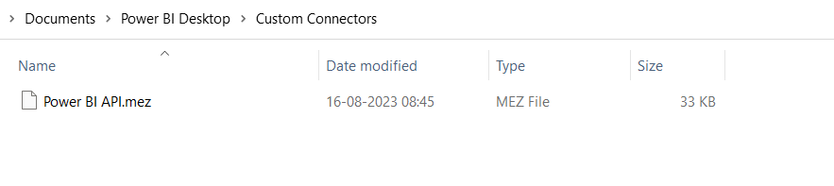

**Make changes in powerbi desktop**

**File** > **Options and settings** > **Options** > **Security**>**Data Extensions**>**(Not Recommended) Allow any extension to load without validation or warning**>**OK**

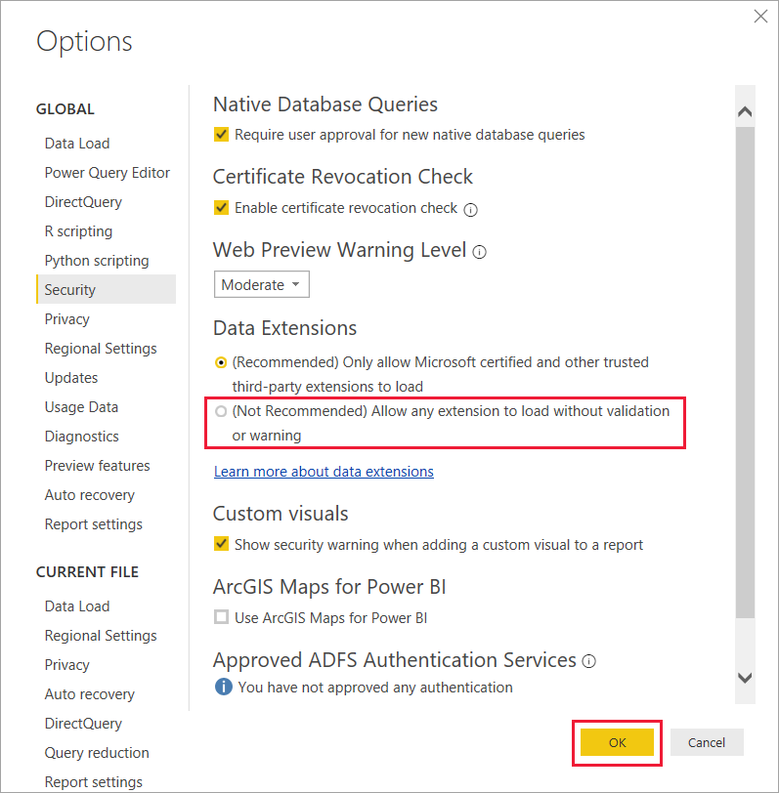

Next step-restart Power BI Desktop.

Powerbi desktop>getdata>power platform>powerbi rest API

Or search with “powerbi rest API” directly in below searchbox

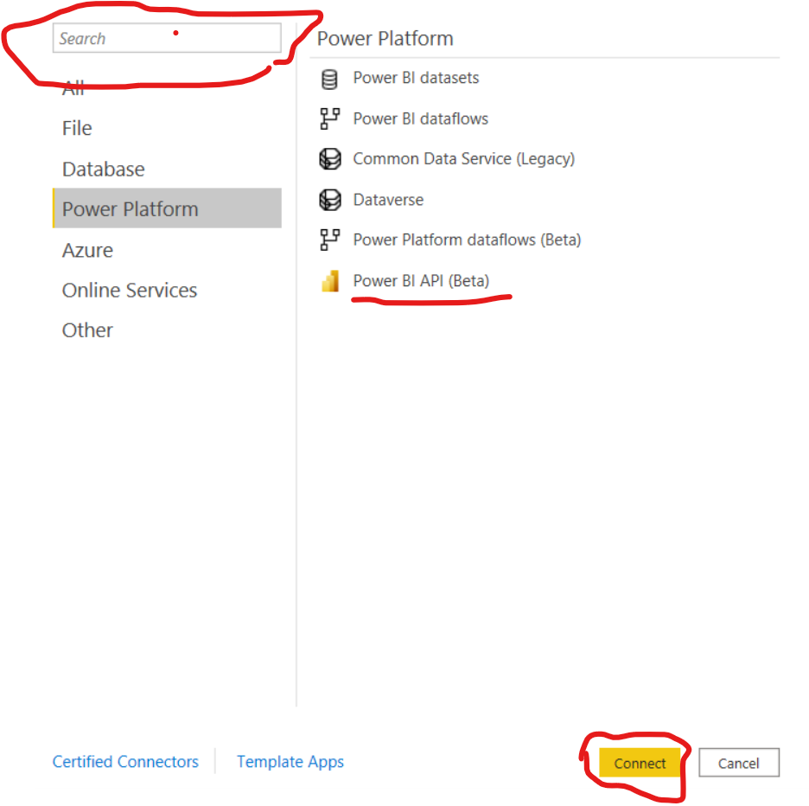

Click on connect>Navigation page

In navigation page select all options workspace and click on load

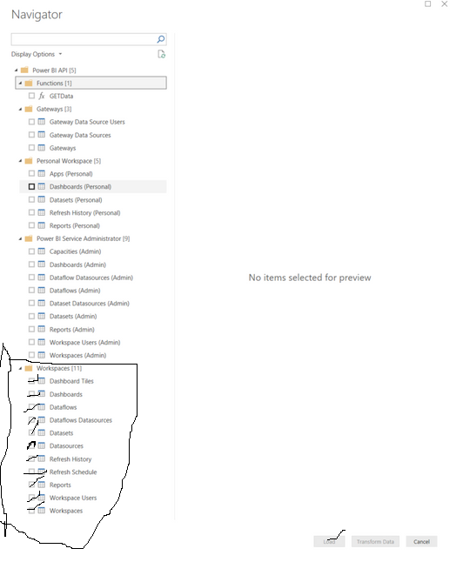

Report view>Develop visuals with Data and publish to powerbi.com

Issues-id’s for workspaces,reports and datasets are available but not names

Fix-Need to create a table includes id’sand names for workspaces,reports and datasets then start developing a report

Usage-

1.These report contains all users and their permissions as per the report,workspace and gateway level.When we migrate report from one workspace to other , Need to export users details in excel then migrate,Later add all users to the new report

2.Admin can see all users details in every level and export data while migrating workspaces/Gateways and implement to provide same access to users in different workspace for same report